0-Healthy   
1-Unhealthy  
2- Out Of Range

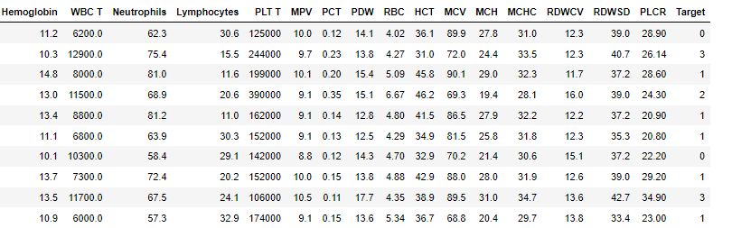3 -Exceptional